

学生实习报告

课程编号： B01045
课程名称： 信息系统实训
学 号： 31701385
姓 名： 钱文鼎
专业班级： 信管1701
所在学院： 计算学院

报告日期： 2020 年 7 月 13 日
实习时间 | 20 19 －20 20 学年 □ 秋季学期 □ 春季学期 暑期短学期  自 2020年 月 日 至 2020年 月 日
实习类型 | □ 认识（社会调查）实习  □ 教学（课程、专题、金工）实习  □ 毕业（综合）实习 | 实习地点 | 理四
实习单位评语：

实习单位（盖章）：

年 月 日
实习指导（带队）教师评语：

实习总评成绩：

教师（签名）：

年 月 日
注：学生的实习总结等文档附在本封面之后

实习总结
使用框架
框架：SpringBoot + layui（前端框架）
数据库：Mysql
开发环境：IDEA

主要功能
主要功能包括：登录注册、发布作业、提交作业、查看作业、作业打分评语、附件上传、生成链接（未实现）

主要可以将系统划分为：登录注册、教师端、学生端

一.登录注册
此功能为教师和学生的公共功能。
在注册时需选择自己的身份。
在登录时会根据选择的身份自动进入学生系统或教师系统。

二.教师端
1.发布新作业
2.查看学生提交的作业
3.给学生提交的作业打分、写评语
4.作业信息统计（提交人数、平均分）
5.生成并分享链接

三.学生端
1.查看老师发布的作业要求
2.提交作业（含附件）
3.查看老师给的分数和评语

暂未实现功能：角色分班、链接生成

数据库设计
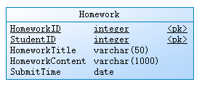
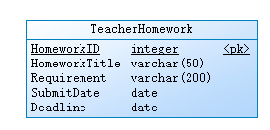
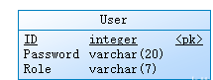

ER图
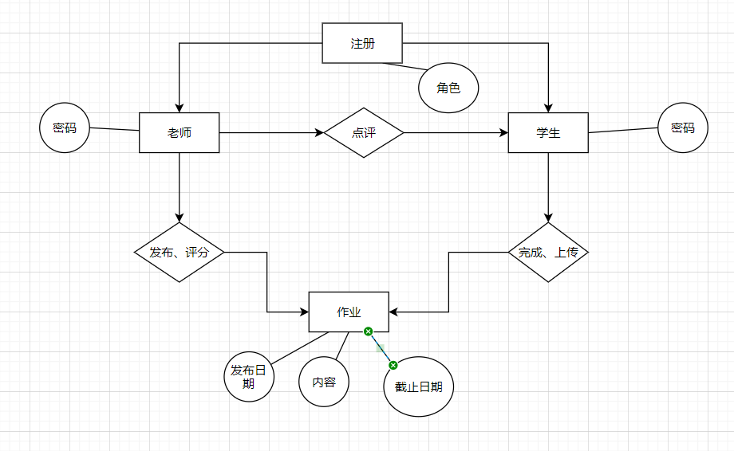

详细设计
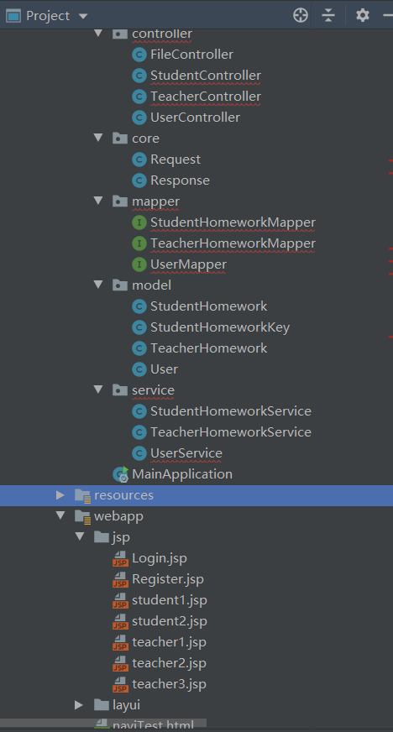

关键代码
老师操作部分：
@RequestMapping("/teacher")
@Controller
public class TeacherController {
final
StudentHomeworkService studentHomeworkService;
final
TeacherHomeworkService teacherHomeworkService;
public TeacherController(StudentHomeworkService studentHomeworkService, TeacherHomeworkService teacherHomeworkService) {
this.studentHomeworkService = studentHomeworkService;
this.teacherHomeworkService = teacherHomeworkService;
}
private static Logger logger = Logger.getLogger(UserController.class);
@RequestMapping("testParam")
public void test(HttpServletRequest req, HttpServletResponse resp){
String homeworkId = req.getParameter("homeworkId");
String studentName = req.getParameter("studentName");
logger.debug("接收到参数 homeworkId ："+homeworkId);
logger.debug("接收到参数 studentName ："+studentName);
}
@RequestMapping("enter")
public void enter(HttpServletRequest req, HttpServletResponse resp)
throws ServletException, IOException {
logger.debug("访问接口：enter");
String userName = req.getParameter("userName");
logger.debug("接收到参数 userName ："+userName);
List<TeacherHomework> list = teacherHomeworkService.findAll();
req.setAttribute("userName",userName);
req.setAttribute("list",list);
req.getRequestDispatcher("../jsp/teacher1.jsp").forward(req,resp);
}
@RequestMapping("requirement")
public void requirement(HttpServletRequest req, HttpServletResponse resp) throws IOException {
logger.debug("访问接口：requirement");
Long homeworkId = new Long(req.getParameter("homeworkId"));
logger.debug("接收到参数："+homeworkId);
TeacherHomework teacherHomework = teacherHomeworkService.findById(homeworkId);
logger.debug("作业要求："+teacherHomework.getRequirement());
resp.setContentType("text/html;charset=UTF-8");
resp.getWriter().write(teacherHomework.getRequirement());
}
@RequestMapping("content")
public void content(HttpServletRequest req, HttpServletResponse resp) throws IOException {
logger.debug("访问接口：content");
Long homeworkId = new Long(req.getParameter("homeworkId"));
String studentName = req.getParameter("studentName");
logger.debug("接收到参数 homeworkId ："+homeworkId);
logger.debug("接收到参数 studentName ："+studentName);
StudentHomeworkKey key = new StudentHomeworkKey(homeworkId,studentName);
StudentHomework studentHomework = studentHomeworkService.findByKey(key);
logger.debug("作业内容："+studentHomework.getHomeworkContent());
resp.setContentType("text/html;charset=UTF-8");
resp.getWriter().write(studentHomework.getHomeworkContent());
}
@RequestMapping("check")
public void check(HttpServletRequest req, HttpServletResponse resp) throws ServletException, IOException {
logger.debug("访问接口：check");
Long homeworkId = new Long(req.getParameter("homeworkId"));
String userName = req.getParameter("studentName");
logger.debug("接收到参数 homeworkId ："+homeworkId);
logger.debug("接收到参数 userName ："+userName);
List<StudentHomework> list = studentHomeworkService.findByHomeworkId(homeworkId);
req.setAttribute("list",list);
req.setAttribute("userName",userName);
req.getRequestDispatcher("../jsp/teacher2.jsp").forward(req,resp);
}
@RequestMapping("start_publish")
public void publish_start(HttpServletRequest req, HttpServletResponse resp) throws ServletException, IOException {
logger.debug("访问接口：start_publish");
String userName = req.getParameter("userName");
logger.debug("接到参数 userName ："+userName);
req.setAttribute("userName",userName);
req.getRequestDispatcher("../jsp/teacher3.jsp").forward(req,resp);
}
@RequestMapping("publish")
public void publish(HttpServletRequest req, HttpServletResponse resp){
logger.debug("访问接口：publish");
String teacherName = req.getParameter("teacherName");
String title = req.getParameter("title");
String requirement = req.getParameter("requirement");
String publishDate_string = req.getParameter("publishDate");
String deadline_string = req.getParameter("deadline");
logger.debug("接收到参数 teacherName ："+teacherName);
logger.debug("接收到参数 title ："+title);
logger.debug("接收到参数 requirement ："+requirement);
logger.debug("接收到参数 publishDate ："+publishDate_string);
logger.debug("接收到参数 deadline ："+deadline_string);
SimpleDateFormat dateFormat = new SimpleDateFormat("yyyy-MM-dd");
Date publishDate = null;
Date deadline = null;
try {
publishDate = dateFormat.parse(publishDate_string);
deadline = dateFormat.parse(deadline_string);
} catch (ParseException e) {
e.printStackTrace();
}
TeacherHomework th = new TeacherHomework();
th.setTeacherName(teacherName);
th.setHomeworkTitle(title);
th.setRequirement(requirement);
th.setPublishDate(publishDate);
th.setDeadline(deadline);
teacherHomeworkService.insert(th);
}
@RequestMapping("score")
public void score(HttpServletRequest req, HttpServletResponse resp){
logger.debug("访问接口 ：score");
Long homeworkId = new Long(req.getParameter("homeworkId"));
String studentName = req.getParameter("studentName");
Integer score = new Integer(req.getParameter("score"));
String comment = req.getParameter("comment");
logger.debug("收到参数 homeworkId ："+homeworkId);
logger.debug("收到参数 studentName ："+studentName);
logger.debug("收到参数 score ："+score);
logger.debug("收到参数 comment ："+comment);
studentHomeworkService.updateScore(studentName,homeworkId,score,comment);
}
@RequestMapping("statistic")
public void statistic(HttpServletRequest req, HttpServletResponse resp) throws IOException {
logger.debug("访问接口 ： statistic");
Long homeworkId = new Long(req.getParameter("homeworkId"));
logger.debug("接收到参数 homeworkId ："+homeworkId);
int count = studentHomeworkService.countHomework(homeworkId);
float avg = studentHomeworkService.avg(homeworkId);
resp.setContentType("text/html;charset=UTF-8");
resp.getWriter().write("提交人数："+count+" 平均分："+avg);
}
}

